­Home Page



Cart Page



1. “Choose a Language” (Arabic/English) option should appear when a user opens the App for the 1st time, after the logo page:



1. After choosing the language, he will be directed to the Home page:
2. The Login page should come after the Completing the cart and proceed page:

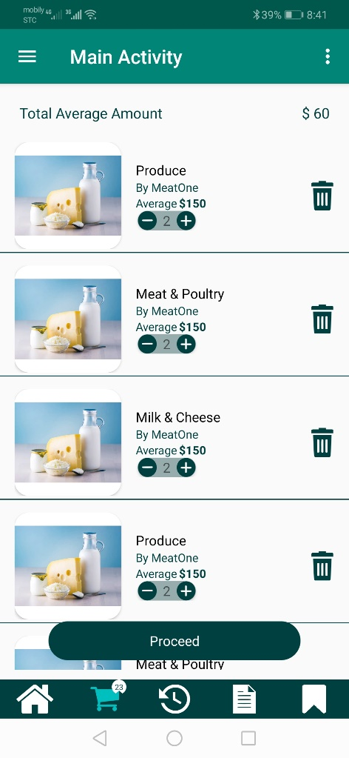



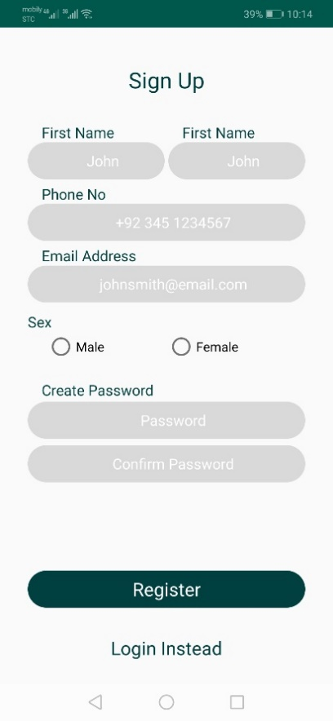 or 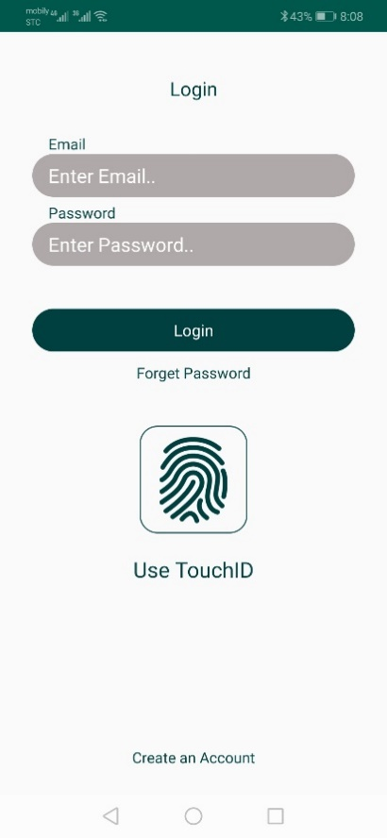

1. After the login/registration page; a “Choose Location” page should come:

 or 

Then will come the results page:

 ➔ 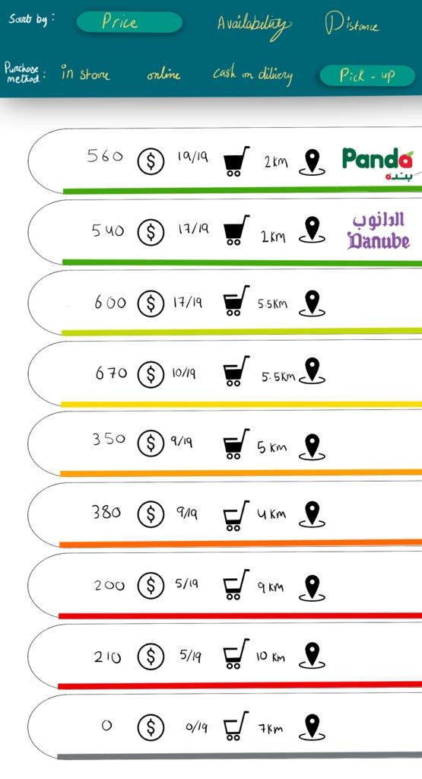

There should be a search option by Barcode in the main page





The password recovery page should have the option to reset the password by mobile number or email address. You should remove the wording “Enter Password..”:

